Universidad Politécnica Metropolitana de Hidalgo

Cervantes Zúñiga Alejandro Ezequiel

Engineering in Infomation Technologies

Cuatrimestre: 1 Group: A

Signature: Industry 4.0

Ing. Javier Elías Barrón López

Topic: Second Code

January-April 2020

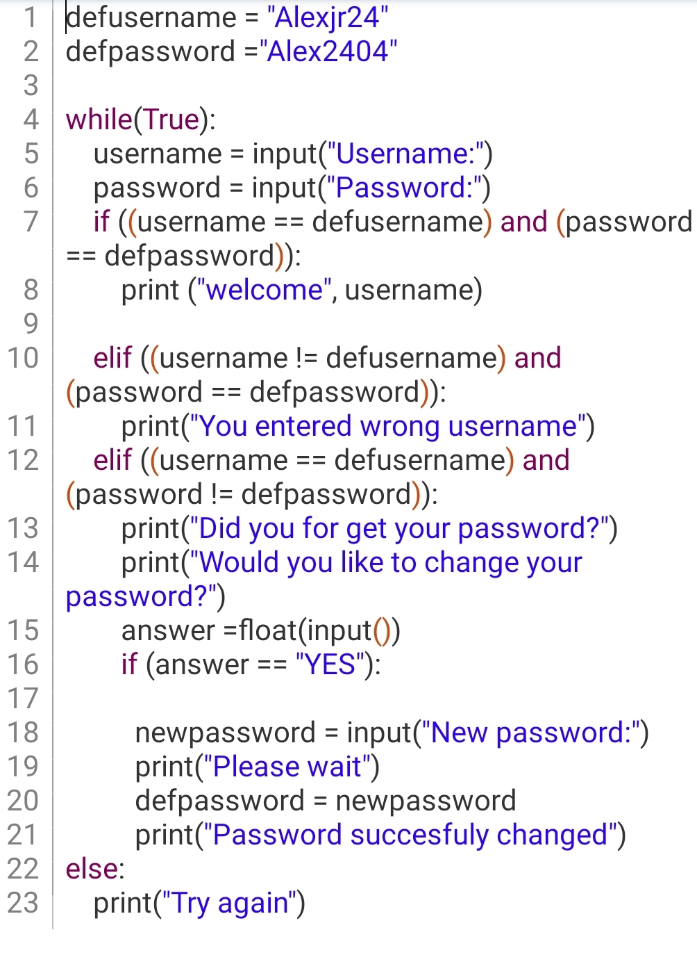In the second code use conditions that is "if, elif, else" use a "While" at the beginning for a truth is not as necessary as occupy "print".

The idea of ​​this code is to enter a user so that you correctly enter the user's name and password so that they welcome you if you do not enter the correct user will tell you but if the password is incorrect it will give you the option to change your password.